 |  | 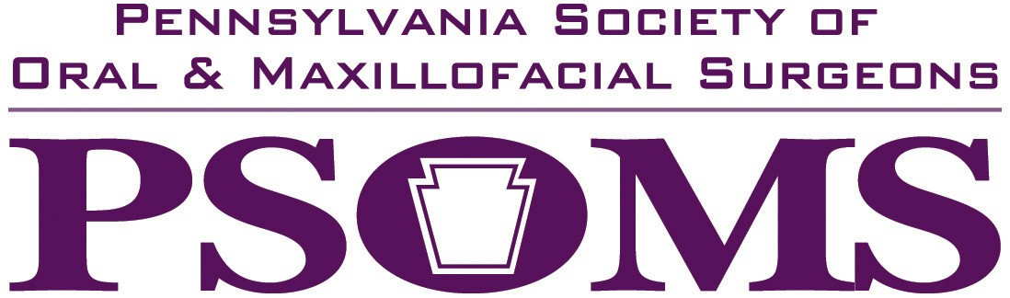
 | DATE: |  | December, 2025 PSOMS tax ID number is 23-2573767
 | TO: |  | ALL EXIBITORS
 | FROM: |  | Christine Corrigan, PSOMS Executive Director (info@psomsweb.org)
 | RE: |  | 2026 Annual Spring Scientific Meeting
 |  |  | Sunday, April 19 & Monday, April 20, 2026
 |  |  | The Omni Bedford Springs Resort, Bedford, PA
 |  |  | Special room rate of $249 available until March 19, 2026 or until block is full. Reservations can be made by calling 1-800-THE-OMNI
 |  |  | When making reservations, please mention PSOMS 2026 Annual Meeting to receive discount.
 | Sunday, April 19 |  | 8:00 am—7:00 pm
 |  |  | Breakfast/Registration/Exhibits
Morning Seminar: Advances in Surgical and Prosthetic Implantology
Afternoon Seminar: Surgical and Prosthetic Considerations for Complex Reconstructive and Rescue Implantology
 |  |  | PSOMS Business Meeting
 |  |  | Cocktail Reception
 | Monday, April 20 |  | 8:00 am—2:00 pm
 |  |  | Breakfast/Registration
Anesthesia Evaluator Course – Michael Bianchi, DDS
PALS Recertification—R. John Brewer, NREMT-P
You are invited to participate in our Annual Spring Scientific Meeting at The Omni Bedford Springs Resort, Bedford, Pennsylvania. We are following the meeting of the Pennsylvania Dental Association so you may see twice as many dental professionals as we have had in the past.

Our space for exhibitors will be limited to the first 16. The exhibitor’s fee is $1300 if paid by January 31, 2026. Payment after January 31, 2026 will be $1500. Your registration includes table, chair, electric, meals and cocktails for one person. Additional staff is $250 per person. Please complete the registration form below and mail with payment made payable to PSOMS and send to PO Box 500, Harrisburg, PA 17108-0500 by March 15, 2026. Please note that we cannot guarantee your spot until payment is received in full. Registration and Credit cards payments can be accepted on our website at www.psomsweb.org by January 10, 2025.

COMPANY NAME (Please list name as you want it to appear in promotional materials) PHONE NUMBER

REPRESENTATIVE NAME(s) EMAIL (This is how you will receive confirmation)

ADDRESS CITY STATE ZIP
Post Office Box 500 Harrisburg, PA 17108-0500 (877) PSOMS-78 (717) 939-7900 fax www.psomsweb.org

